Invention Disclosure Form 
Part 1: Applicant & Inventor Personal Details
Applicant Details | Name | Mobile No. | Gender | Email ID | Address | District
1st Applicant | Geethanjali College of Engineering and Technology | 986608271 |  | info@gcet.edu.in | Sy. No. 33 & 34, Cheeryala(V), Keesara(M),Medchal-Malkajgiri(D), Telangana - 501301 | Medchal – Malkajgiri
2nd Applicant | Dr. G. Neeraja Rani | 9951752754 | Female | neerajarani.fe@gcet.edu.in | Geethanjali College of Engineering and Technology, UGC Autonomous, Cheeryala(V),  Keesara(M), Medchal -Malkajgiri(D), Telangana – 501301 | Medchal - Malkajgiri
3rd Applicant | Dr. B. Nagamani | 9121793919 | Female | nagamani.english@gcet.edu.in | Geethanjali College of Engineering and Technology, UGC Autonomous, Cheeryala(V),  Keesara(M), Medchal -Malkajgiri(D), Telangana – 501301 | Medchal - Malkagiri
4th Applicant | Sreeja Chilamanthula | 6300233197 | Female | 24r11a05dw@gcet.edu.in | H.No:3-128 Gowtham Nagar Colony,Patacheru,Sanagreddy(D),Telangana 502319 | Sangareddy
5th Applicant | Mandal Tejaswini | 9704259418 | Female | 24r11a6668@gcet.edu.in | Plot no 189 beside sai rao residency, saikrupa colony, yapral.  Medchal-500087 | Medchal – Malkajgiri
6th Applicant | Chatla Shrija | 8639437007 | Female | 24r11a66m5@gcet.edu.in | SLNR Nilayam , 3-13-100/53 BEL Road,Baba Nagar ,Near Sacchitananda Apartment,Mallapur, Hyderabad, Telangana, Dattatreya Nagar, BEL, Industrial Development Area, Mallapur, Secunderabad, Telangana 500076 | Medchal Malkajgiri
7th Applicant | B Shivamurthi | 7416010978 | Male | 24r11a6703@gcet.edu.in | 5-49  Junni,  Mandal: Ichoda  District: Adilabad  State: Telangana 504307 | Adilabad
8th Applicant | D Reethika | 8142325306 | Female | 24r11a0209@gcet.edu.in | Huzurnagar  Mandal: Huzurnagar  District : Suryapet  Telangana 508204 | Suryapet
Inventor Details | Name | Mobile No. | Gender | Email ID | Address | District
1st Inventor | Dr. G. Neeraja Rani | 995175274 | Female | neerajarani.fe@gcet.edu.in | Geethanjali College of Engineering and Technology, UGC Autonomous, Cheeryala(V),  Keesara(M), Medchal -Malkajgiri(D), Telangana – 501301 | Medchal – Malkajgiri
2nd Inventor | Dr. B. Nagamani | 9121793919 | Female | nagamani.english@gcet.edu.in | Geethanjali College of Engineering and Technology, UGC Autonomous, Cheeryala(V),  Keesara(M), Medchal -Malkajgiri(D), Telangana – 501301 | Medchal - Malkajgiri
3rd Inventor | Sreeja Chilamanthula | 6300233197 | Female | 24r11a05dw@gcet.edu.in | H.No:3-128 Gowtham Nagar Colony,Patacheru,Sangareddy(D),Telangana 502319 | Sangareddy
4th Inventor | Mandal Tejaswini | 9704259418 | Female | 24r11a6668@gcet.edu.in | Plot no 189 beside sai rao residency, saikrupa colony, yapral.  Medchal-500087 | Medchal - Malkajgiri
5th Inventor | Chatla Shrija | 8639437007 | Female | 24r11a66m5@gcet.edu.in | SLNR Nilayam , 3-13-100/53 BEL Road,Baba Nagar ,Near Sacchitananda Apartment,Mallapur, Hyderabad, Telangana, Dattatreya Nagar, BEL, Industrial Development Area, Mallapur, Secunderabad, Telangana 500076 | Medchal Malkajgiri
6th Inventor | B Shivamurthi | 7416010978 | Male | 24r11a6703@gcet.edu.in | 5-49  Junni,  Mandal: Ichoda  District: Adilabad  State: Telangana 504307 | Adilabad
7th Inventor | D Reethika | 8142325306 | Female | 24r11a0209@gcet.edu.in | Huzurnagar  Mandal: Huzurnagar  District : Suryapet  Telangana 508204 | Suryapet

Point of Contact for Search & Draft Team from researchers – Sreeja Chilamanthula

Part 2: Description of Invention
Q.1 – Have you ever disclosed your invention publically to your friends/family or published it in journals? Any presentation/pitch you would have made regarding your invention?
Ans. No

Q.2 – Provide a short brief on the problem your invention is trying to solve.
Ans. Pregnancy brings about dramatic physical changes, particularly a growing belly and shifting center of gravity, which make restful sleep increasingly difficult. While many pregnant women turn to standard or even specialized pillows, most existing solutions fall short—they lack adaptability, targeted support, and multifunctional design. Current pillows often do not provide adequate belly support, strain relief for the back and shoulders, or postural alignment, and they typically serve only a single purpose. As a result, pregnant women are forced to adjust with makeshift combinations of pillows, leading to disrupted sleep, increased body pain, and daily discomfort. There is a clear gap in the market for a thoughtfully designed, ergonomic, and versatile solution that evolves with a woman's needs during and after pregnancy.

Q.3 – Do you know any prior inventions that are currently targeting the same problem you are trying to solve?
Ans. Yes, there are several pregnancy pillows already available in the market that aim to provide comfort to expecting mothers. Common types include C-shaped, U-shaped, and wedge pillows, each designed to support specific parts of the body such as the back, belly, or knees. For example:
- C-shaped pillows provide full-body support but may be bulky and difficult to adjust.
- U-shaped pillows offer head-to-toe comfort but often lack modularity and take up a lot of bed space.
- Wedge pillows offer localized support but are limited in versatility.
However, most of these products are single-purpose and non-customizable. They are not designed to be used beyond pregnancy, nor do they combine multiple support features in one product. Unlike these existing designs, our invention is a multi-functional and detachable pregnancy pillow that not only aids in sleep but also serves as a feeding pillow, wedge support, and lumbar support, making it more adaptive and useful through all stages of motherhood.

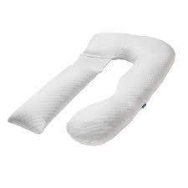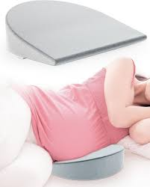

Q.4 – Title of the Invention (Provide a title fitting the technical description of the invention and not a brand name)
Ans. – "Multi-Functional Maternity Support Pillow with Detachable Ergonomic Components"

Q.5 – Materials/Apparatus/Dimensions/Formulae/Components used for the preparation of invention (Depending on your invention)
Ans. – 1. Main U-Shaped Pillow (Head, Neck & Feeding Support)
- Material: High-resilience memory foam or microfiber filling
- Cover: Soft, breathable cotton or bamboo fabric (skin-friendly and washable)
- Function:
  - Provides support for head, neck, and shoulders during sleep
  - Can be repositioned as a feeding pillow post-pregnancy
- Special Design: Center-stitch circle enhances airflow or allows optional fastener

2. Detachable Side Body Pillow (Vertical Segment with Dual Function)
- Material: Firm PU foam or polyester fiberfill
- Texture: Basket-weave stitched for comfort and durability
- Functions:
  - Belly Support: Helps pregnant women maintain side-sleeping posture
  - Lumbar Support: Can be positioned behind the lower back to reduce pain and improve spinal alignment while sitting or lying
- Attachment Mechanism: Adjustable Velcro/snap buttons for easy reconfiguration

3. Leg Support Segment (Lower Horizontal Part)
- Material: Medium-density memory foam
- Function: Aligns hips, knees, and legs for ergonomic positioning
- Attachment: Connected with 3 adjustable buckles for flexibility

4. Detachable Wedge Pillow (Right Side Attachment)
- Material: Angled firm foam
- Function:
  - Belly support or reclining aid while sitting
  - Can be detached and used separately
- Attachment: Dual straps or side clips for stability

5. Integrated Hot/Cold Pack Pockets
- Location:
  - Inside the wedge pillow
  - In the lumbar area of the side body pillow
- Material: Heat-resistant inner lining
- Function: Accommodates reusable gel-based hot/cold packs for targeted pain relief (lower back, belly, or shoulders)

6. Fastening & Adjustment Mechanisms
- Types: Velcro strips, plastic buckles, and snap buttons
- Purpose:
  - Allows modular adjustment based on sleeping or sitting position
  - Enables quick conversion between pregnancy and postnatal uses

📏 Approximate Dimensions (Can be Customized):
Component | Dimensions (L × W × H in cm)
U-Shaped Pillow | 60 × 50 × 15
Side Body/Lumbar Pillow | 80 × 25 × 15
Leg Support Segment | 30 × 20 × 10
Wedge Section | 25 × 20 × 10 (angled)
Hot Pack Pockets | ~15 × 10 (variable by pack)

Q.6 – Non-Obviousness/Novelty. What exactly is unique from the other solutions present in the world? How does it benefit the invention and its’ efficiency?
Ans. – Our invention stands out through its modular, multi-functional design that integrates five distinct support roles into a single, reconfigurable system — something not commonly found in existing pregnancy pillows.
Unique Features Compared to Existing Solutions:
- Modular Configuration:
  - The pillow consists of detachable parts: a U-shaped headrest, side body/lumbar pillow, leg support, and a wedge module, all of which can be rearranged or used independently.
  - Most existing products are fixed in shape and serve only one or two purposes (e.g., sleep or belly support only).
- Dual-Function Components:
  - The U-shaped section doubles as a feeding pillow after pregnancy.
  - The side body pillow provides both belly and lumbar support, depending on placement.
  - This smart use of form increases utility without increasing size or cost.
- Thermal Therapy Pockets:
  - Integrated hot/cold pack pockets in targeted areas (wedge and lumbar zones) allow therapeutic relief for lower back pain, swelling, and muscle cramps — a feature not available in common pillows.
  - This enhances both comfort and medical efficiency.
- Compact, Convertible Design:
  - Unlike bulky U- or C-shaped pillows that take up space, this pillow can be disassembled and used selectively, making it ideal for both home and travel use.
- Post-Pregnancy Usability:
  - Most pregnancy pillows lose utility after childbirth. Ours converts into a nursing pillow, backrest, or lumbar cushion, extending its life cycle and value.

How This Improves the Invention’s Efficiency:
- Versatility eliminates the need for multiple separate products.
- User customization allows mothers to adjust support based on trimester, body type, or activity (sleeping, feeding, resting).
- Pain relief integration with heat/cold pockets improves user well-being and reduces the need for external therapy tools.
- Efficient design makes it cost-effective, space-saving, and sustainable.
This level of non-obvious integration of ergonomic support + thermal therapy + postpartum utility makes the invention distinctly novel and highly efficient compared to conventional, single-purpose maternity pillows.

Q.7 – Provide basic working principle used for conduction of process to create invention. What fundamental principles are being used here?
Ans. Our invention relies on three core fundamentals:
- Ergonomic Load-Distribution
  - Principle: Evenly dispersing body weight reduces pressure points.
  - Application: Contoured foam segments cradle the head, belly, lumbar curve, knees, and legs, keeping the spine neutral and muscles relaxed.
- Modular Biomechanics
  - Principle: Independent, re-configurable supports can target different anatomical zones as needs change.
  - Application: Detachable U-shape, wedge, side body, and leg pieces let users realign support for trimester changes, nursing posture, or lumbar relief—maintaining correct joint angles and circulation.
- Thermotherapy & Thermoregulation
  - Principle: Local heat improves blood flow and eases muscle tension; cold reduces inflammation.
  - Application: Built-in pockets hold reusable hot/cold gel packs, delivering targeted temperature therapy without separate equipment.

Q.8 – Any specific clause/feature/point you wish to include within the Claim Sets of the Patent Application?
Ans. – We would like to include the following unique features in the claim set of the patent application:
- Modular Detachable Structure
  - A pregnancy pillow system composed of multiple detachable segments—including a U-shaped headrest, side body/lumbar support, wedge, and leg rest—configured for customizable ergonomic use.
- Dual-Function Components
  - A U-shaped section that functions both as a headrest during pregnancy and as a feeding pillow post-pregnancy.
- Integrated Thermal Therapy Pockets
  - Strategically placed pockets within the pillow structure designed to hold hot or cold gel packs for targeted pain relief (especially lumbar and belly areas).
- Multi-Stage Usability
  - A system designed for continuous use during and after pregnancy, including sleeping, sitting, feeding, and resting applications.
These features collectively define the novelty, functional versatility, and therapeutic advantage of our invention and should be protected under the patent claim set.

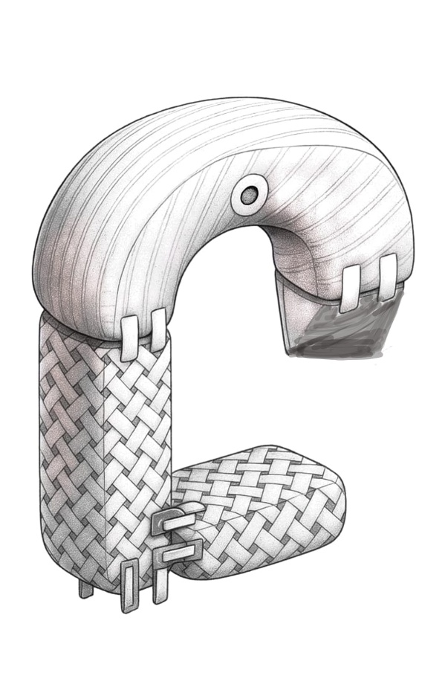
Q.9 – Provide drawings in AUTOCAD, along with a flowchart/step-by-step of the working model of an invention.
Ans. – A. AutoCAD Drawings

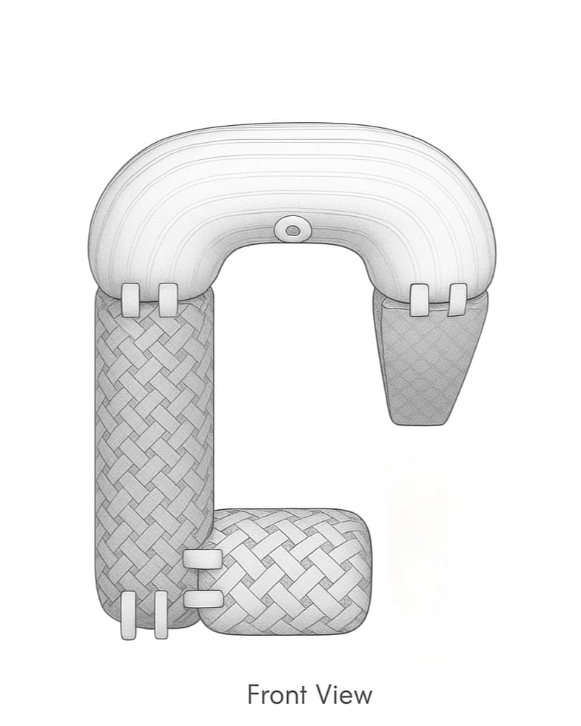

Isometric View Front View

B.Flowchart: Working Model of Multipurpose Pregnancy Pillow
Start
↓
User selects configuration based on need:
• Sleeping – attach all parts
• Feeding – use U-shaped section only
• Lumbar support – use side pillow & wedge
• Leg support – attach lower segment
↓
User inserts hot/cold gel packs (if required):
• Side pillow (lumbar)
• Wedge (belly)
↓
User lies down or sits using the assembled pillow:
• Spinal alignment
• Belly/back/knee support
↓
Comfort and pain relief achieved through ergonomic support + thermal therapy
↓
Adjust or disassemble after use
↓
End

Q.10 – Any other details you feel are necessary to be included in the Patent Application such as a “Specific Drawings, Code, Description, Tool used”
Ans. To support the novelty, functionality, and reproducibility of our invention, the following additional details are proposed for inclusion in the patent application:

1. Specific Technical Drawings
- Orthographic views (top, front, side) and isometric drawings created from the hand-drawn concept sketch
- Exploded view showing individual detachable components: U-shaped pillow, side body/lumbar pillow, leg support, and wedge
- Component labeling for ergonomic zones, thermal pack pockets, fasteners (Velcro, buckles), and curvature dimensions

2. Material Specifications
- Detailed descriptions of foam density, fabric type (e.g., hypoallergenic cotton), and heat-resistant lining for thermal pack pockets
- Notes on modular attachment mechanisms (Velcro, snap buttons, straps)

3. Digital Flowchart
- Flowchart describing the step-by-step working model included in Word format to visualize usage configurations and therapeutic integration

4. Tools Used
- Design & Drafting: AutoCAD for 2D/3D technical illustrations
- Visualization: AI-powered rendering (used to simulate real-life look and feel)
- Prototype Testing: Manual stitching, foam cutting, and fastening trials using basic upholstery tools and stitching kits

5. Description of Functional Flexibility
- Emphasize the multi-stage usability (prenatal, postnatal, therapeutic)
- Highlight the convertibility of the U-shaped part into a feeding pillow
- Document how component adjustability increases ergonomic accuracy
